Hybrid backscattering model by a prolate spheroid
Dezhang Chu
Created on January 5, 2024
Revised on March 26, 2024

The resonance scattering by a prolate spheroid (Ye, 1997):
$f_{bs_{0}}^{res} =\frac{a_{esr}F_{Spheroid}^{2}}{\left(\frac{{ω_{0}}_{esr}^{2}}{ω^{2}}\right)F_{spheroid}-1-ika_{esr}F_{spheroid}^{2}}$ (1)
where
$ω_{0_{esr}}=\frac{2π}{a_{esr}}\sqrt{\frac{3γP_{e}}{ρ_{w}}}$ (2a)
$ω_{spheroid}=ω_{0_{esr}}F_{spheroid}^{1/2}$, (2b)
$F_{spheroid}^{1/2}=2^{\frac{1}{2}}e_{ac}^{-\frac{1}{3}}{\left(1-e_{ac}^{2}\right)}^{\frac{1}{4}}{\left[\ln\left(\frac{1+\sqrt{1-e_{ac}^{2}}}{1-\sqrt{1-e_{ac}^{2}}}\right)\right]}^{-\frac{1}{2}}$ (2c)
where $e_{ac}=\frac{a}{c}<1$is the aspect ratio, the ratio of semi-minor to semi-major axis, and $e_{ac}=1$ for the case of a sphere. It is easy to verify that $F_{spheroid}^{}=1$ for $e_{ac}=1$, i.e., for the case of a sphere.
The corresponding differential backscattering cross section is then
$σ_{bs_{0}}^{res}(ka_{esr})={\left|f_{bs_{0} }^{res}\right|}^{2}=\frac{a_{esr}^{2}F_{spheroid}^{2}}{{\left[{\left(\frac{ω_{0_{esr}}}{ω_{}}\right)}^{2}F_{spheroid}^{2}-1\right]}^{2}+k^{2}a_{esr}^{2}F_{spheroid}^{2}}$, (3)

To add the angle of orientation dependent term, we use a Sinc function
$Θ(θ)= \frac{sin⁡(kc\sin{θ}) }{kc\sin{θ}}$, (4)
where $θ$ is the angle of orientation of the prolate spheroid (normal of the major axis) relative to the incident wave. The combined scattering angle-dependent scattering model is then
$σ_{bs}^{res}(ka_{esr},θ)=Θ(θ )σ_{bs_{0}}^{res}(ka_{esr}$) (5)
For $ka_{esr}≫1, or as ka_{esr}→∞$, from the Kirchoff Approximation when frequency is very high, Eq. (64) of Gaunuard (1985) and for $r, R≫a_{1}, a_{2}>λ$
$σ_{bs}^{asymp}\left(θ\right)=\frac{a_{1}(θ)a_{2}(θ)}{4}$ (6)
It can be derived that for an ellipsoid with incident wave in the X-Z plane,
$σ_{bs}^{asymp}(θ)=\frac{σ_{bs_{0}}e_{ac}^{4}}{{\left(\sin^{2}{θ}+e_{ac}^{2}\cos^{2}{θ}\right)}^{2}}$, (7)
where $σ_{bs_{0}}=σ_{bs}(0)$ is the broadside incidence:
$σ_{bs_{0}}=\frac{c^{2}}{2a}\left(\frac{b^{2}}{2a}\right)=\frac{c^{2}}{4}e_{ba}^{2}$, (8)
where$e_{ba}=\frac{b}{a}$ and $e_{ba}=1$ for a prolate spheroid.
We construct a following transition function (a transient response of a passive electric system to a step function, Alexander et al., 2013):
$σ_{bs}^{hybrid}\left(ka_{esr}, θ\right)=\left[σ_{bs}^{asymp}(θ)-σ_{bs}^{res}(k_{T}a_{esr},θ)\right]\left(1-e^{-α(ka_{esr}-k_{T}a_{esr})}\right)+σ_{bs}^{res}(k_{T}a_{esr},θ)$, (9)
where $k_{T}$ is the wave number corresponding to the frequency where the transition starts, $α$ is a parameter governing the transition rate.
$TS^{hybrid}=10\log_{10}{σ_{bs}^{hybrid}\left(ka_{esr}, θ\right)}$ (10)
Comparison of this analytical model with the numerical simulations using the Boundary Element Method (BEM) is shown in Fig. 1, where we plot the reduced target strength (RTS) as a function of $ka_{esr}$.
$RTS^{hybrid}=10\log_{10}\left(\frac{σ_{bs}^{hybrid}\left(ka_{esr}, θ\right)}{σ_{bs_{0}}}\right)$. (11)

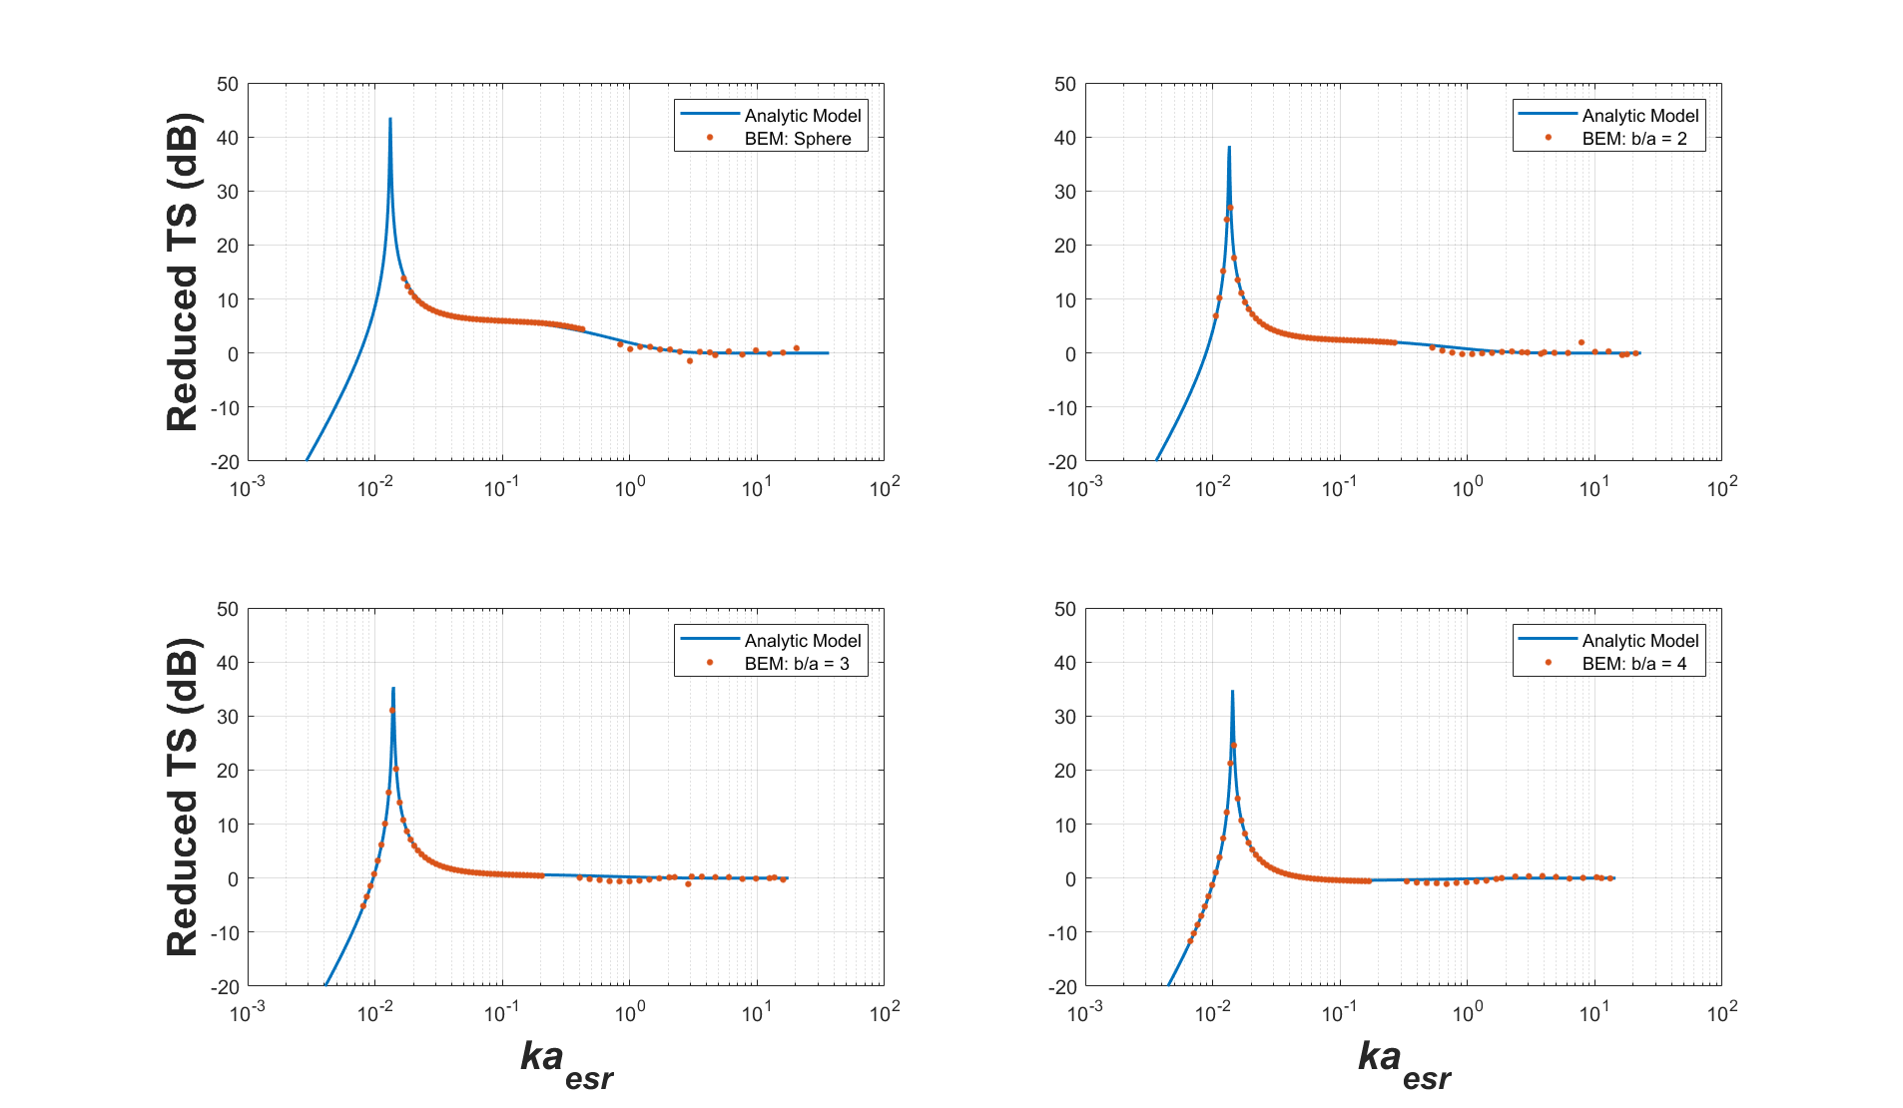
Figure 1. Comparison between the analytical model for prolate spheroids (Eq. 9) with the BEM simulations for aspect ratios of 1 (sphere), 2, 3, and 4, respectively, where the y-axis is the Reduced Target Strength, and x-axis is the dimensionless quantity $ka_{esr}$. In Eq. (9), a transition parameter $k_{T}a_{esr}=0.1$ and $α=1.3$ are used in the hybrid model.

References
Gaunaurd, G. C. 1985. Sonar cross sections of bodies partially insonified by finite sound beams, IEEE J. Ocean. Eng. 10: 213-230.
Ye, Z. 1997. Low-frequency acoustic scattering by gas-filled prolate spheroids in liquids. J. Acoust. Soc. Am., 101: 1945-1952. https://doi.org/10.1121/1.418225

